Bug Report
Project: CodeGalaxy: An Agentic AI Based Interactive Programming Learning Platform
Batch No. 8
Harsh Kumar 2311CS040064
Abhishek Pratap Kushwaha 2311CS040003
Aditya Raj 2311CS040006

Bug Title
Intermittent Display Issue – Visualizer / Code Editor Option Missing in Challenges Section
Bug Description
On the LMS Challenges page, users intermittently experience an issue where the code visualizer / interactive element does not load or display inside the challenge cards/section.
While the coding challenges (e.g., Two Sum, Reverse String, Valid Anagram) are visible along with their metadata, the expected visualizer interface or standard interaction options fail to render completely.
Expected Behavior
When accessing the Challenges page or opening a specific coding challenge card, the corresponding visualizer, problem workplace, or visual execution tool should consistently render and display without breaking.
Actual Behavior
The visualizer component occasionally fails to display inside the challenges section, resulting in an incomplete view for the user where visual assets or execution tools are missing.
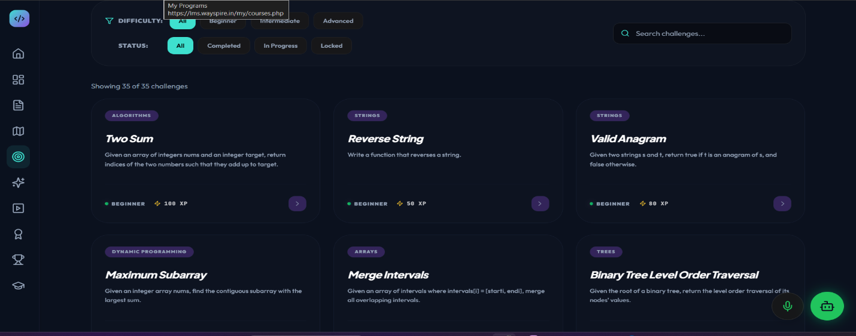
Bug Title
Security / Design Flaw – Unverified Certificate Authentication Display in Certificates Module
Bug Description
On the Certificates dashboard (127.0.0.1:8080/certificates), the generated certificate displays badges such as "AUTHENTIC CREDENTIAL" alongside a Verification ID (CG-2026-DSA99) and QR code section.
However, the authentication displayed on the certificate is static/hardcoded and lacks real cryptographic or backend verification logic. The QR code or Verification ID either does not route to a public validation endpoint, or marks certificates as authentic without validating against a secure issuer authority or database ledger.
Expected Behavior
The certificate should only display an "AUTHENTIC CREDENTIAL" badge if it undergoes real-time backend verification (e.g., checking a public key, digital signature, or cryptographic hash stored in the issuer backend). Clicking or scanning the Verification ID/QR code should redirect the user to a public, tamper-proof verification page confirming validity.
Actual Behavior
The certificate shows static authentication indicators ("AUTHENTIC CREDENTIAL") without performing actual cryptographic/backend authentication, resulting in non-functional or misleading credential validation.
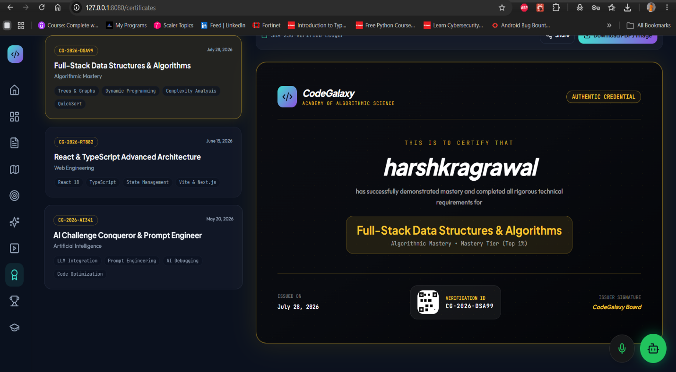
Bug Title
Data Synchronization Flaw – Leaderboard Displays Static / Unsynchronized XP Points
Bug Description
On the Leaderboard page (127.0.0.1:8080/leaderboard), the XP displayed for the active user on the leaderboard list (e.g., #02 harshkragrawal showing 460 XP) and user rank banner (YOUR RANK: #10) does not sync or match the user’s real-time account profile XP (showing 100 XP in the top-right header and rank banner).
The leaderboard appears to rely on static, hardcoded, or unsynchronized data rather than querying and reflecting the user’s actual database XP score and ranking dynamically.
Expected Behavior
The leaderboard should fetch real-time user progress from the backend database. The user's current XP shown in the navigation bar/profile header (e.g., 100 XP) should accurately match their entry in the leaderboard list, and their rank (YOUR RANK) should dynamically reflect their real place based on that score.
Actual Behavior
The leaderboard displays incorrect or static XP values (e.g., listing 460 XP on the board while the user actually has 100 XP), causing a mismatch between the navbar profile state, the global rank card, and the leaderboard table.
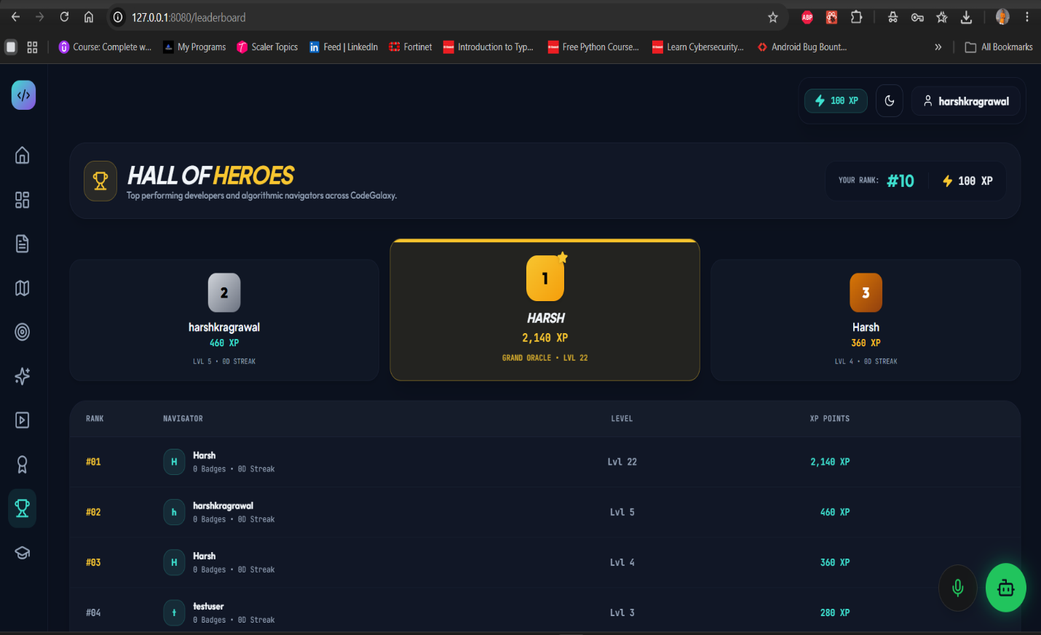
Bug Title
Content Deficit – Incomplete and Sparse Curriculum Nodes in Learning Path Section
Bug Description
On the Learning Path page (127.0.0.1:8080/learning-path), under the Navigation Hub (e.g., JavaScript track), the interactive developer roadmap contains inadequate module nodes and sparse instructional content.
The interactive tree ends abruptly after minimal progression levels (e.g., showing only a single Level 1 node), lacking comprehensive learning materials, sub-topics, or milestone challenges required for a complete skill track.
Expected Behavior
The Learning Path should render a fully fleshed-out, multi-stage roadmap containing comprehensive modules, branching skill levels, practical exercises, and structured topics spanning foundational to advanced levels for the selected track.
Actual Behavior
The Learning Path section displays minimal content nodes, leaving the developer roadmap largely empty and lacking sufficient learning materials for effective user progression.
